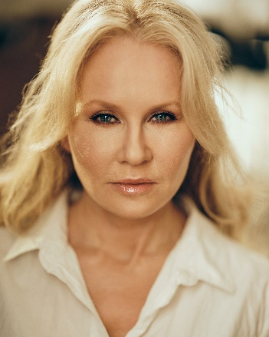
Tara Devitt

Height: 5 ft, 3 inches
Size: 10
Hair: Blonde
Eyes: Blue

Email: tara.devitt@gmail.com
Ph 089 4286966 Represented by Delaney Grey Management

Experience
Television Role Part Director
Fair City Support Court Register Sam Atwell
Fair City Support Nurse Jim Shields
Dreamers (Episode 1) Support Woman in Park Tony Deehan

Feature Film Role Part Director
Dublin Crust Support Stacey Baz Black
Suit Hung, Tied Tongue Lead Yvonne Moore Sau Dachi
The Troubles – A Dublin Story Support Cath – Café Owner Luke Hanlon

Short Film
Blackmail Support Head of School Kyle Ohlendieck
Justice Support Maura - Parent Courtney McDonald
The Truth behind your Eyes Principal Gina-Parent Courtney McDonald
The Boyfriend Principal Sarah-Parent David Brazin
Moonshine Support Big Kate-Crime Boss Jeff Donnelly
Meet the Parents Principal Mary-Parent Mark Sewell
Choices Principal Mary-Parent Chris Killingbeck

Other
Fighting Words Programme Actor Roddy Doyle

Training School Date
Ultimate Acting Programme Brian Timoney Actors Studio 2020
Advanced Screen Acting Bow Street 2019
Screen Acting Bow Street 2018

Awards Special Skills Accents
Winner/Fireside Monologue Competition Yoga Teacher Dublin/Irish
Twice Finalist Fishpond Monologue Challenge Bodhran Player Gen American

