Tara Devitt
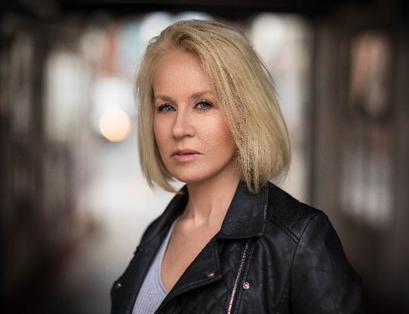
Height: 5 ft, 3 inches
Size: 10
Hair: Blonde
Eyes: Blue

Email: tara.devitt@gmail.com
Ph 089 4286966 Represented by Bloom Artist Management

Experience
Television Role Part Director
Fair City Support Nurse Jim Shields
Dreamers (Episode 1) Support Woman in Park Tony Deehan
Film Role Part Director
The Troubles – A Dublin Story Support Cath – Café Owner Luke Hanlon
The Delivery Support Jill Jane Shirley
Blackmail Support Head of School Kyle Ohlendieck
Justice Support Maura - Parent Courtney McDonald
The Truth behind your Eyes Principal Gina-Parent Courtney McDonald
Martina’s Baby Support Shop Customer Mervyn McCracken
The Boyfriend Principal Sarah-Parent David Brazin
Moonshine Support Big Kate-Crime Boss Jeff Donnelly
Meet the Parents Principal Mary-Parent Mark Sewell
Choices Principal Mary-Parent Chris Killingbeck
When I was Cruel Support Margaret-Parent Daniel Doyle

Other
Fighting Words Programme Actor Roddy Doyle

Training School Date
Ultimate Acting Programme - Method Brian Timoney Actors Studio 2020
Advanced Screen Acting Bow Street October 2019
Psychology of Acting Clusterfox Films May 2019
Screen Acting Bow Street August 2018
General American Accent Bow Street December 2018
Acting for Camera Gaiety School of Acting May 2018
Audition/casting Masterclass Gaiety School of Acting January 2018

Awards Special Skills Accents
Winner/Fireside Monologue Competition Yoga Teacher Irish
Finalist/Fishpond Monologue Challenge Bodhran Player Dublin

